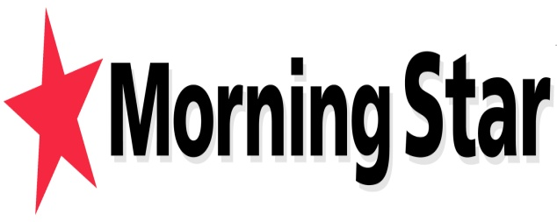
Trade Union Freedom:
Working against Austerity
WEDNESDAY 17 APRIL 12.30 p.m.
PERTH THEATRE, HIGH STREET
3 minutes from conference venue
BOB CROW, President of CTUF
MARY ALEXANDER, UNITE
RICHARD BAGLEY, Editor
Chair: Phil McGarry, RMT
The Coalition government has waged an all-out, coordinated, ideological and class based attack on the very foundations of our country. April 2013 will be forever known as the turning point when the arrogant posh boys fundamentally undermined the NHS, the welfare benefit system, employment rights and access to justice all within one week.
Little wonder that community opposition is growing, strikes are on the increase and trade unions are once again discussing how best to coordinate a labour movement backed response to the ConDem’s austerity measures.
Trade unions are the only organised group able to turn the neoliberal tide – but to do that we need to win the argument for our alternative, economic, industrial and political strategy. The recent launch of the Campaign for Trade Union Freedom is one strand of resistance. The pages of the Morning Star another - offering a daily dose of alternative, socialist strategies. UNITE and RMT remain at the forefront of publicly resisting ConDem attacks.
Come to the meeting, hear from our speakers and add your voice to the rising tide of resistance.
Richard Bagley will outline steps being taken to make the Morning Star an effective media force in Scotland – with the new full-time reporter Rory Mackinnon and the half price sales drive being launched this week jointly with the Cooperative.
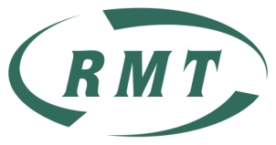 Refreshments available, kindly sponsored by UNITE Scotland 